Western Bay of Plenty Ostomy Society Inc
Promotional Display Days
As a result of winning the 2022 Coloplast Award we decided that we would spend the time and money to hold a number of Ostomy display days around the region and to that end we have done 4. The first was at The Tauranga Crossing shopping mall and we were situated outside of the entrance to The Warehouse and while initially we were not too sure as to how this would go we actually found it to be quite ideal. This was run by Les & Dian, Barbara & Nic, Richard and Sue.
A week later we held the second one in Taupo at the entrance to the Taupo Mitre 10 Mega just on the outskirts of town and Les & Dian held the fort themselves as there was no one else to back them up.
The third was held indoors at Bayfair shopping centre near the McDonalds outlet and again Le & Dian started things off (Richard got the time schedule stuffed up in his mind and got there late to take over from them!) and then Stella helped out in the afternoon.
The final one was at Papamoa Plaza outside of the Paper Plus store which Richard started and handed over to Rose & Shirley and then Doug before Richard returned to do the final stint and then closed everything down.
We averaged around 30 people or families spoken to at each venue and were quite astounded at how many young people actually knew about Ostomies mainly due to Tic Toc which was probably a good use for the platform. It also showed them that Ostomies are not just for old people. And we also encouraged younger people who did not know about us to look up Ostomy on social media.
Les did Stirling work at talking to people as a support person which was a different angle top come from as the rest of us were mainly Ostomates.
We will not really know what the benefits will have been unless someone joins and says that they saw us there. A number of people that I spoke to already had ostomies or had reversals. So hopefully down the track we will see some results of our efforts. I was particularly struck by a you Maori lady at Papamoa who came up to the display, looked for a while and then asked “are these Ostomy bags” I said that they were and she said “My brother had one for bowel cancer and he died 6 years ago, I wish that I had known about your organisation before as maybe you could have helped us, his mother has never got over her son’s death and never have I”
We want to thank Les and Dian’s son who supplied the Ostomy labelled sweets of which a huge number were given away.
We may look at doing this again next year we will just have to see how things go.
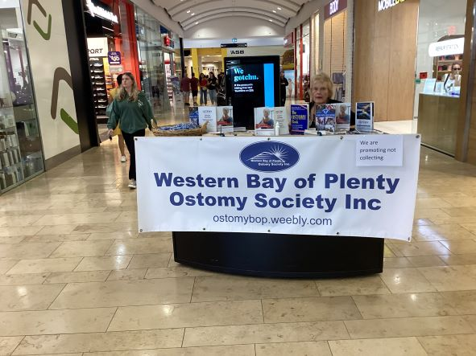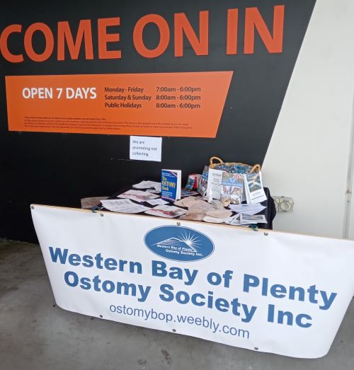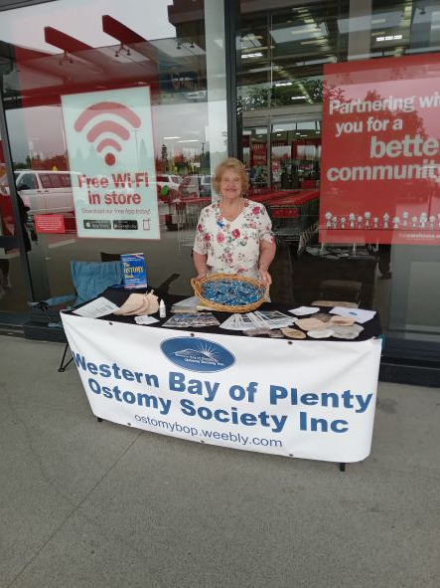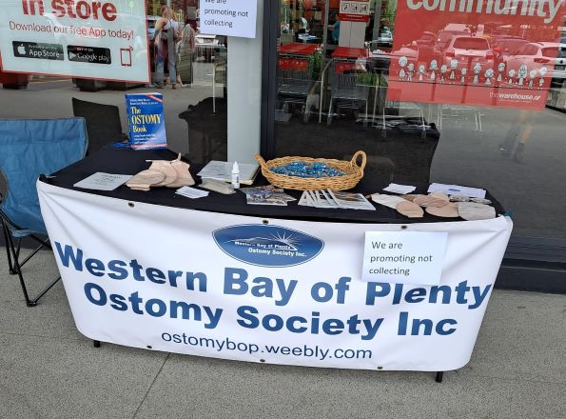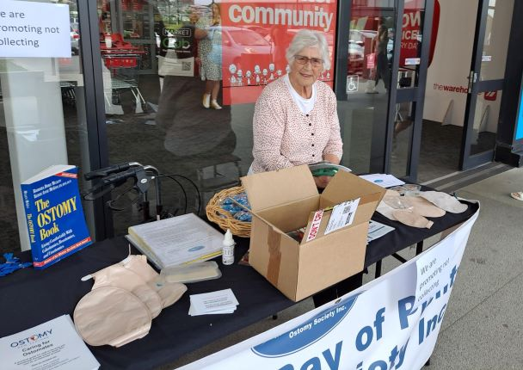
This is the display at the Bayfair shopping centre
This is a photo of the display at Mitre 10 Taupo and was situated in the entrance way.
Display at Tauranga Crossing
These are taken at the Tauranga Crossing display

